
B.M.S. COLLEGE OF ENGINEERING
(Autonomous college under VTU)
Bull Temple Rd, Basavanagudi, Bengaluru, Karnataka 560019
2025-2027
Department of Computer Applications

Report is submitted for fulfillment of AAT work in the subject
“WEB TECHNOLOGIES”
(MMC103)
By
Khushi Prabhu (1BM25MCA052)
Chandana K (1BM25MCA004)

Under the Guidance
Dr. V Padmapriya
(Assistant Professor)

CONTENTS

SL. No. | Programs | Page No.
1 | Introduction
2 | Features
3 | Wireframe
4 | Navigation
5 | Screenshot of the website
6 | References

AAT Final Report
Title: VARNA VILAS
- Introduction
This report provides an overview of the website developed for Vilas Nayak, a renowned speed painting artist known for his dynamic performances and artistic excellence. The website is designed to highlight his creative journey, artworks, live performances, achievements, and contact information in a visually engaging and user-friendly format.

It features essential sections such as the Home Page, Gallery Page, About Page, Events Page, and Contact Page to offer a smooth and intuitive browsing experience.

The primary objective of the website is to establish a strong digital presence for Vilas Nayak, allowing visitors to explore his portfolio, learn about his artistic accomplishments, and connect for event bookings or collaborations.

This report outlines the development process, design considerations, key features, and overall impact of the website, emphasizing how it effectively represents the artist’s brand and creative identity.

Goals of the VARNA VILAS website are:
1. Showcase Artistic
2. Promote Brand
3. Provide Information
4. Facilitate Event and Booking Inquiries
5. Engage Visitors Through Interactive
6. Provide Updates on Events

- Features
1. Home Page
- Welcoming introduction to Vilas Nayak, highlighting his identity as a renowned speed painting artist.
- Visually engaging banner images showcasing live painting performances and iconic artworks.
2. About Page
- Detailed background of Vilas Nayak and his artistic journey.
- Information about his inspiration, creative philosophy, and artistic evolution.
3. Gallery Page
- Curated collection of professional images from live performances, exhibitions, and completed artworks.
- Well-organized image layout for smooth browsing and visual clarity.
4. Arts Page
- Dedicated section showcasing customized and commissioned artworks created by Vilas Nayak.
- Detailed visual display of paintings based on themes such as culture, spirituality, heritage, and personal commissions.
5. Shows Page
- Information about live painting performances, stage shows, exhibitions, and cultural events.
- Visual representation of performances with brief descriptions.
6. Contact Page
- Contact form for event bookings, customized artwork inquiries, and collaborations.
7. Social Media Integration
- Link to social media platforms like Instagram.

- Wireframe Design
HOME
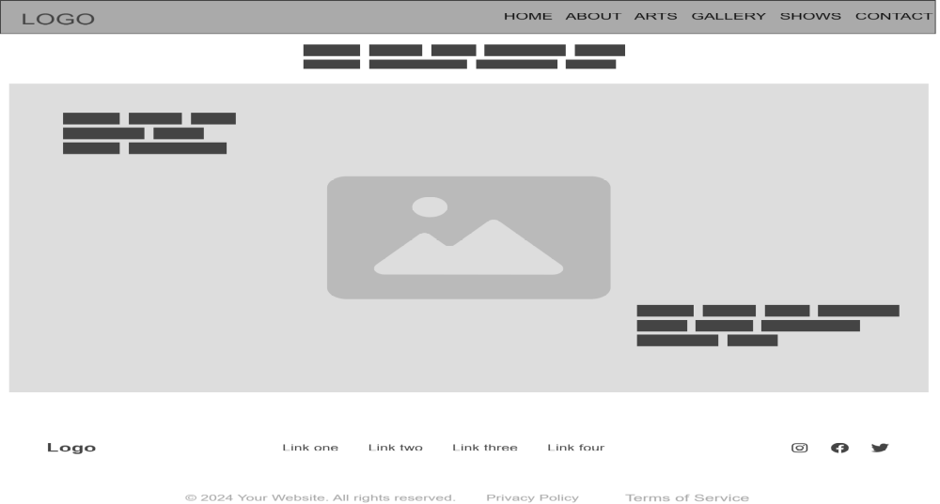

ABOUT
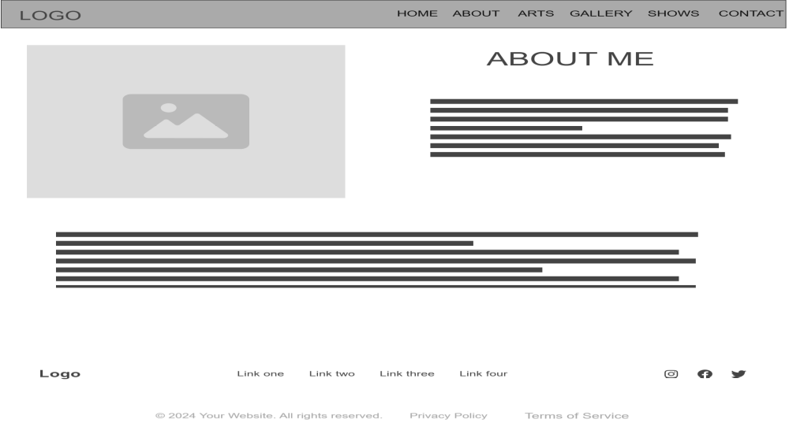

ARTS
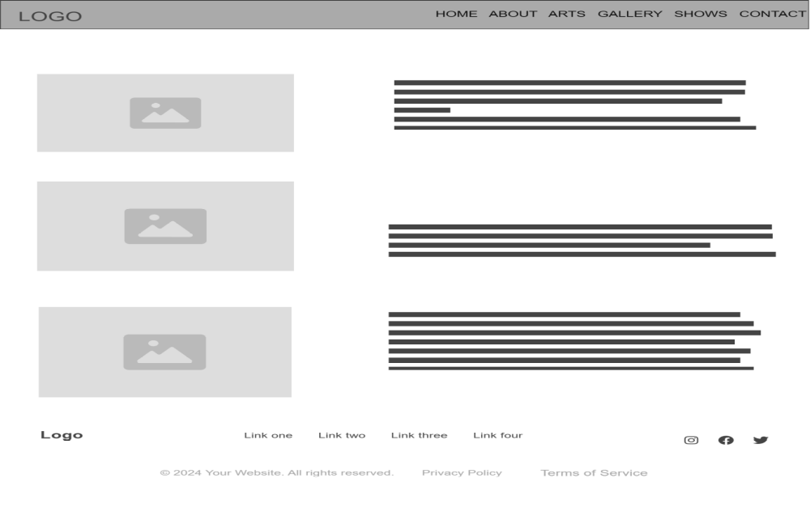

GALLERY
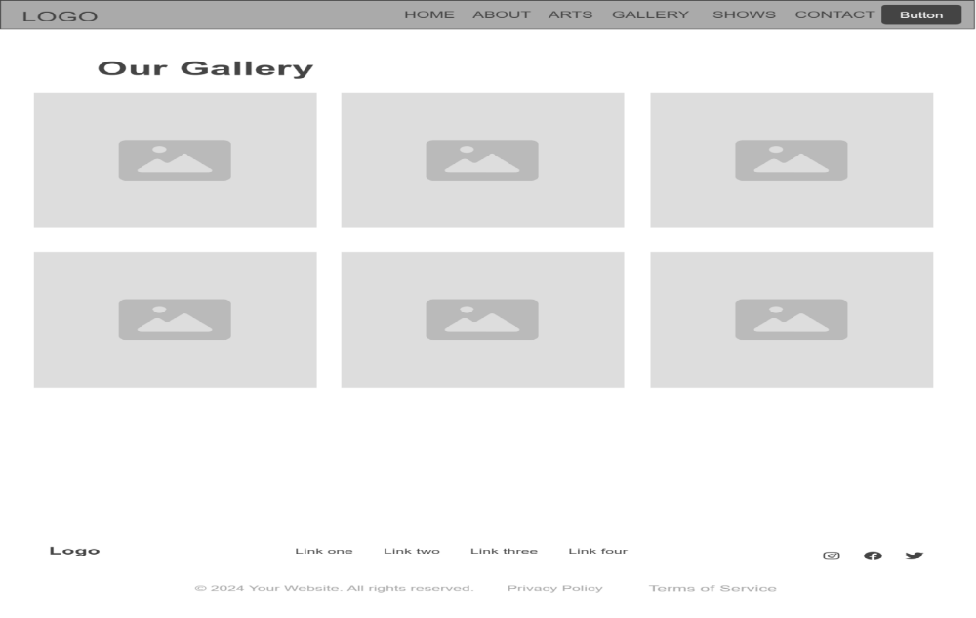

SHOWS
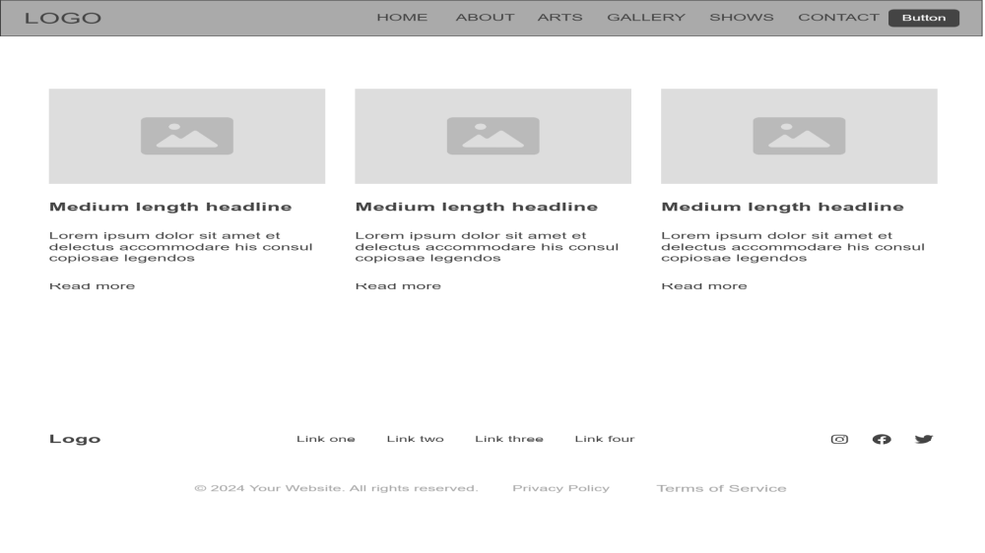

- NAVIGATION

- Screenshots of the website

- References
https://www.raghudixit.com

